**INVENTORYMANAGEMENTSYSTEM FOR RETAILERS**

**Domain:** Cloud Application Development

**Team id: PNT2022TMID48008**

|  |  |  |  |
| --- | --- | --- | --- |
| **Team Members:** | **M.Janani** | - | 912319104015 |
|  | **M.Bavadharani** | - | 912319104003 |
|  | **J.Devi priya** | - | 912319104006 |
|  | **S.Pavithra** | - | 912319104026 |

Create an account in send Grid

# SendGrid Setup

How to setup Sendgrid for use in OneSignal Email Messaging

[Suggest Edit s](https://documentation.onesignal.com/edit/sendgrid-setup)

OneSignal's Email Messaging requires the use of a third-party email service provider to handle email delivery. All you have to do is set up the integration between the provider and OneSignal, and you'll be ready to send emails through OneSignal.

# Step 1. Requirements

* [SendGrid Account](https://www.sendgrid.com/)
* [OneSignal Account](https://onesignal.com/)

# Step 2. SendGrid Sender Authentication

It is recommended to use SendGrid's "Domain Authentication" so that SendGrid sends emails via your domain rather than via sendgrid.net, and the links your users click as coming from your domain.

## Install DNS Records

If you selected **Domain Authentication** make sure your DNS Records are verified.

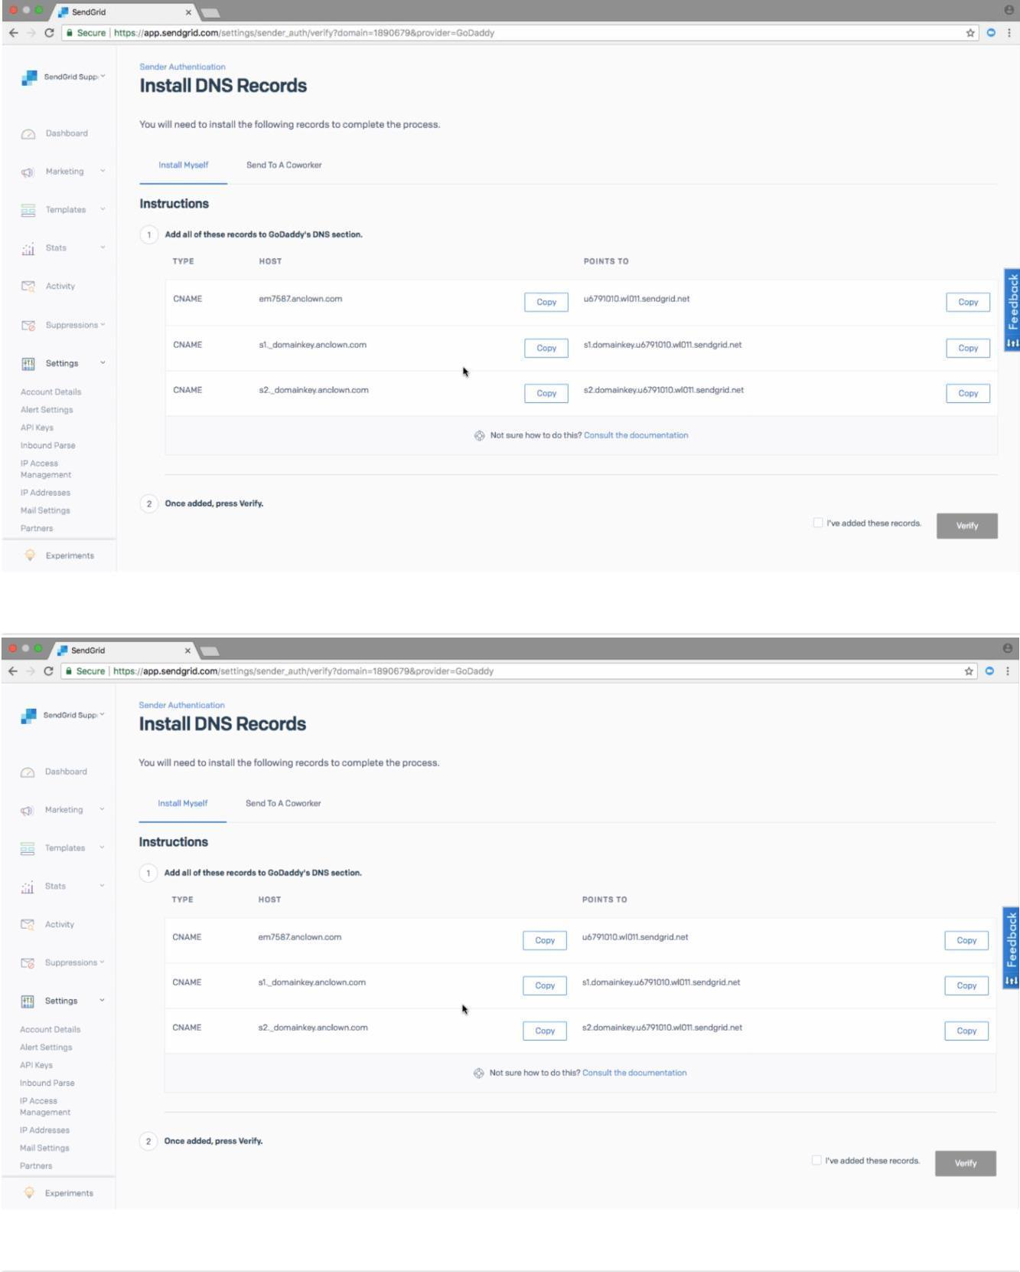

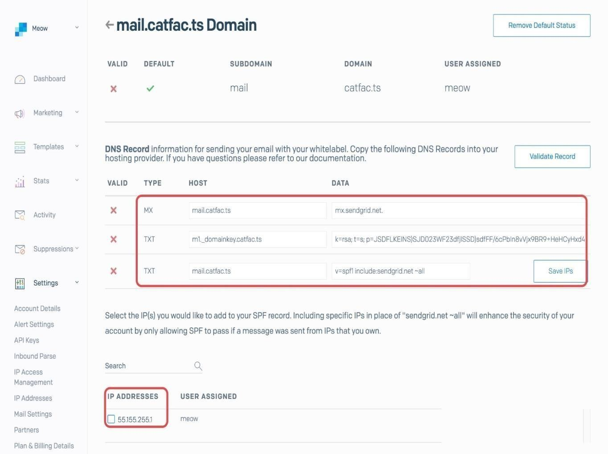

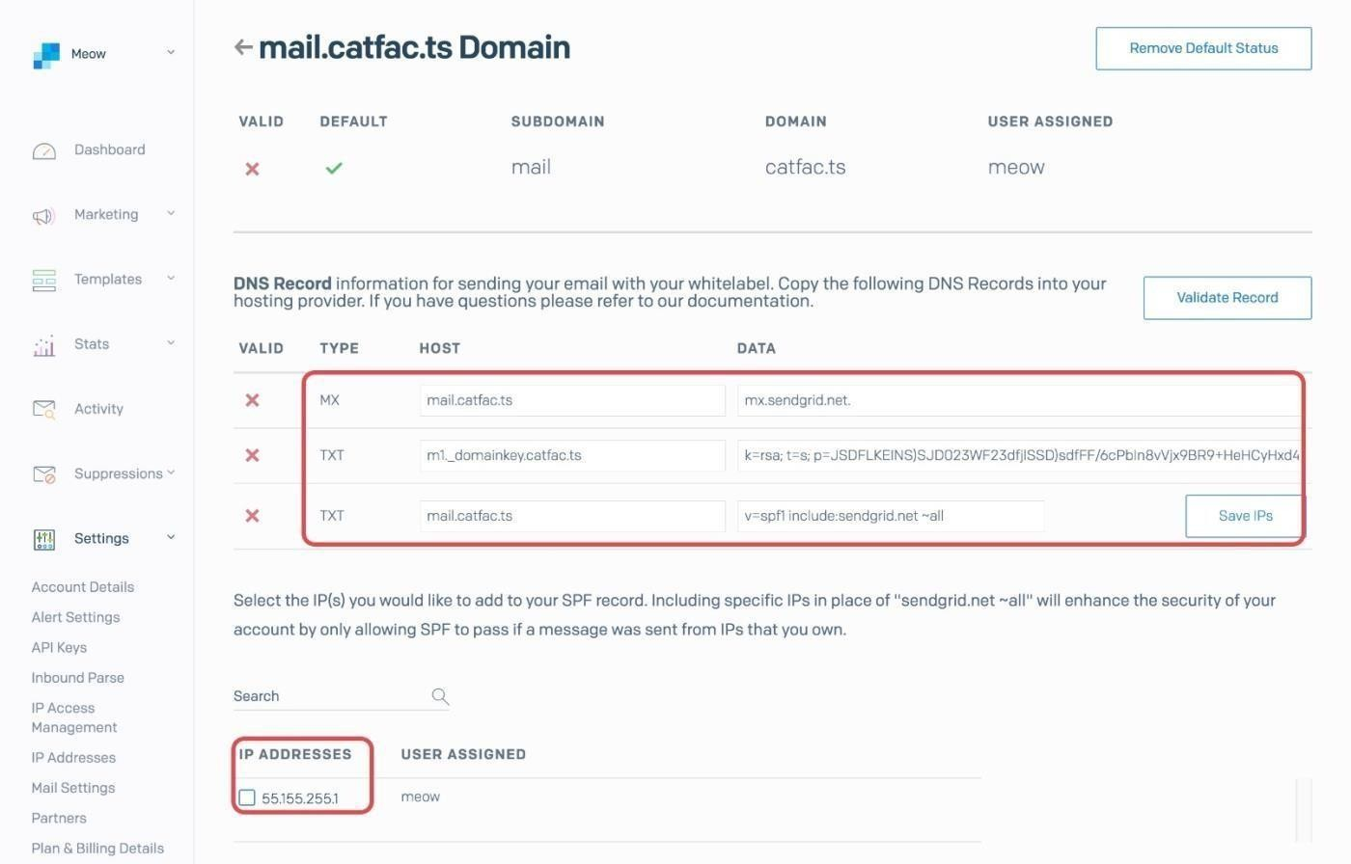

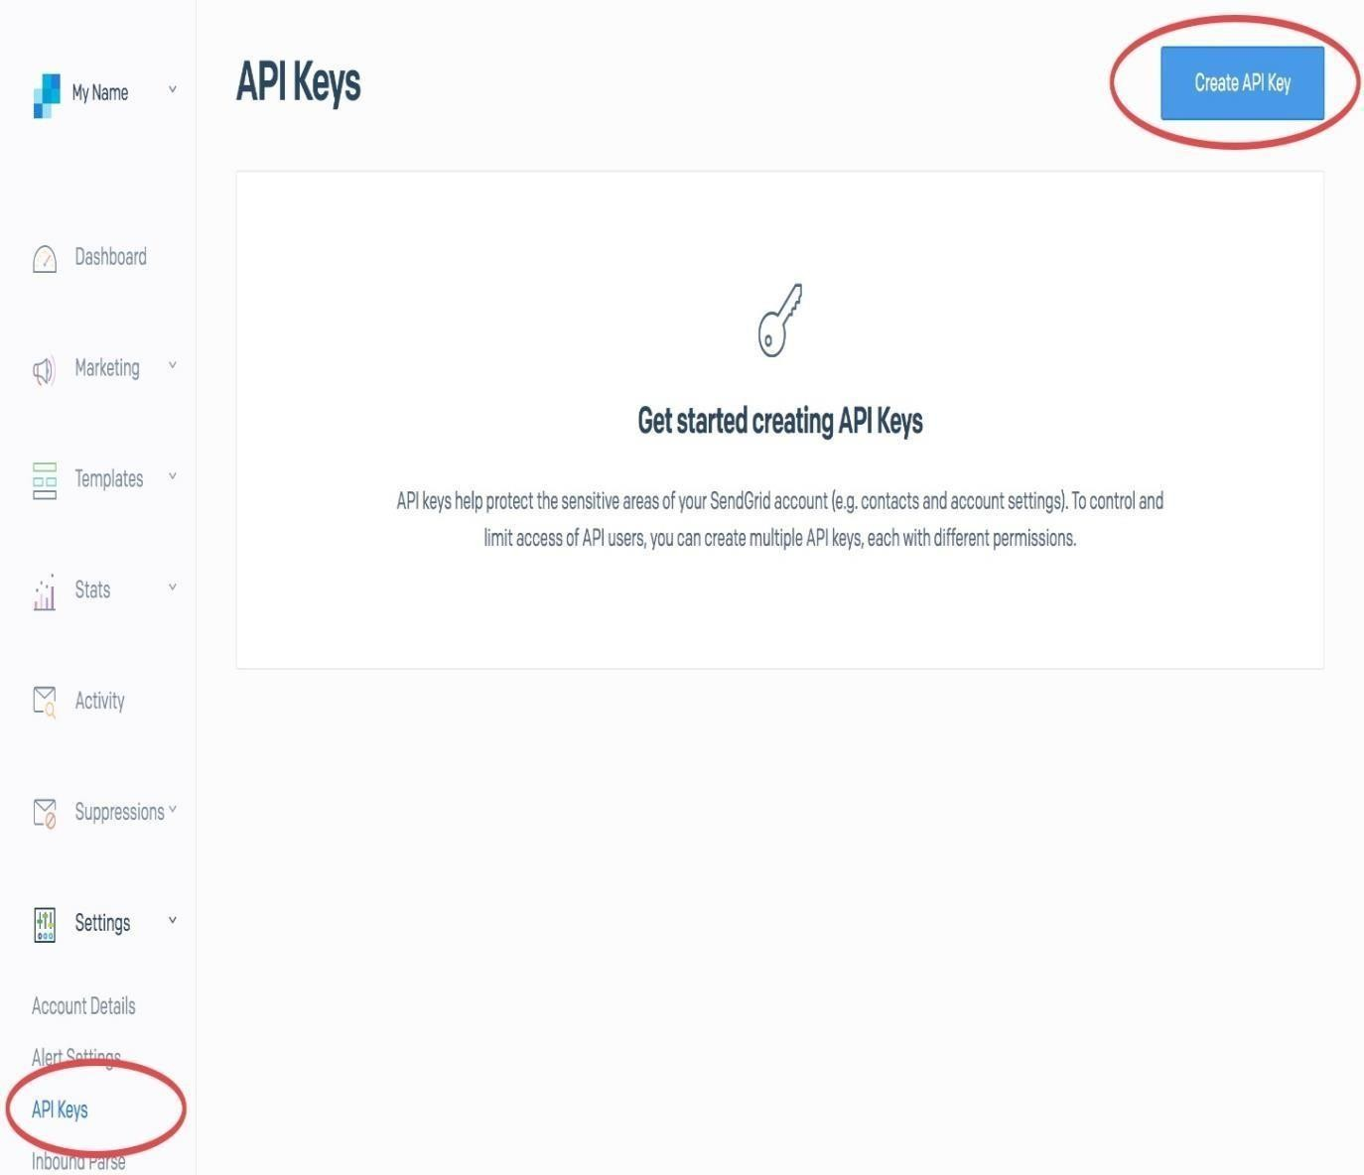

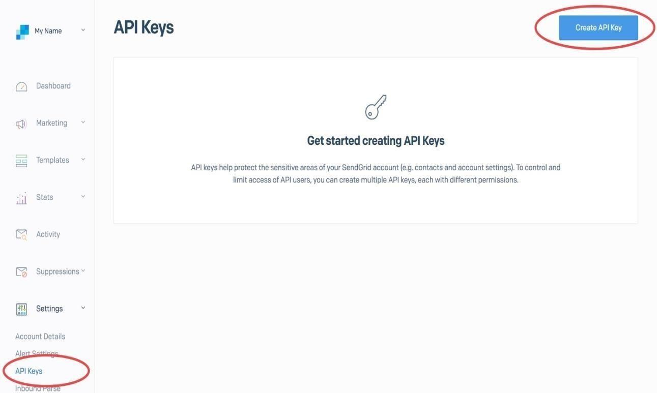

Name your API key something like OneSignal API Key and be sure to set permissions to **Full Access**. Click 'Create & View' when you are ready.

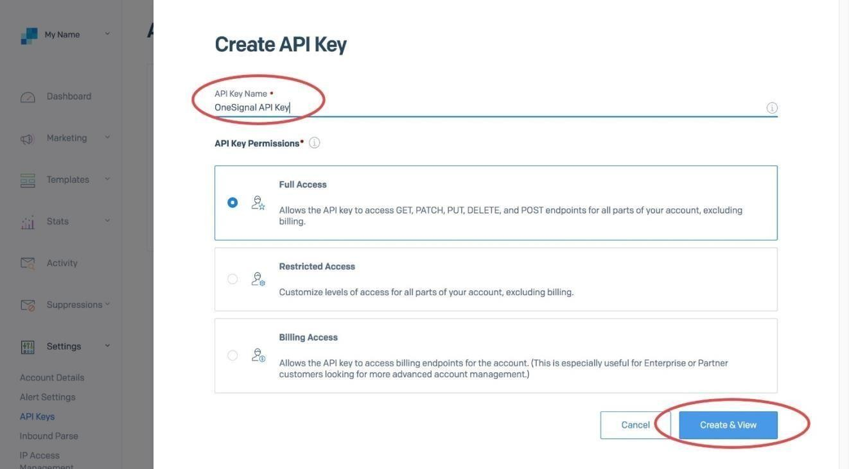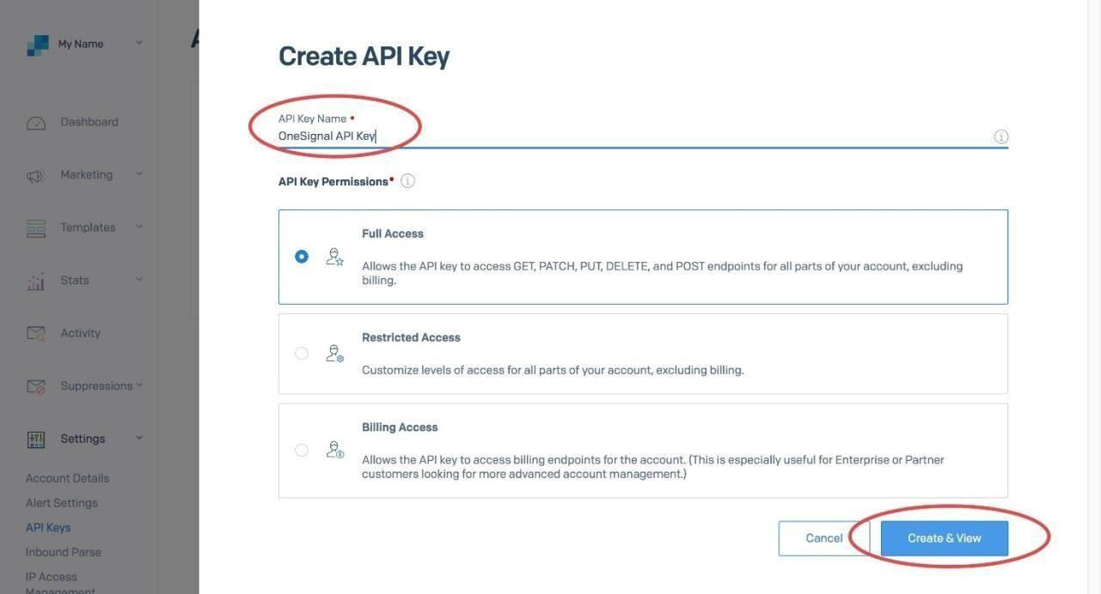

Next, click on the API key to copy it to your clipboard.

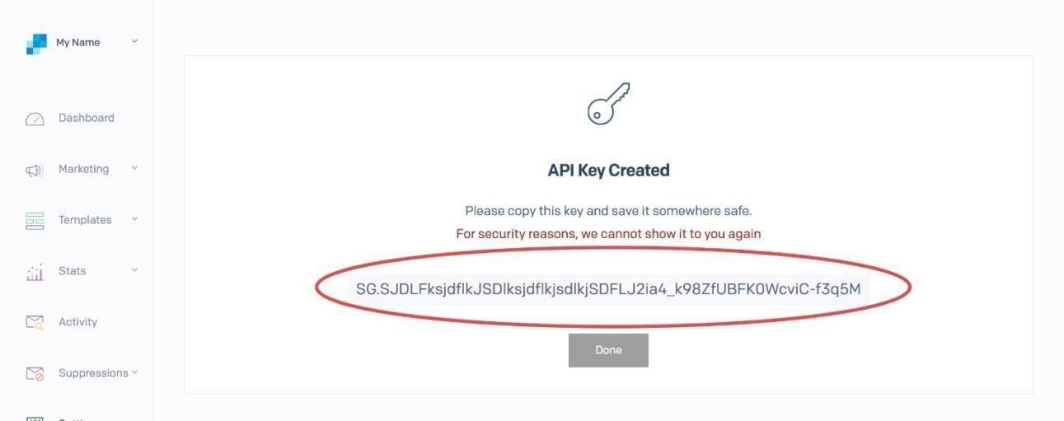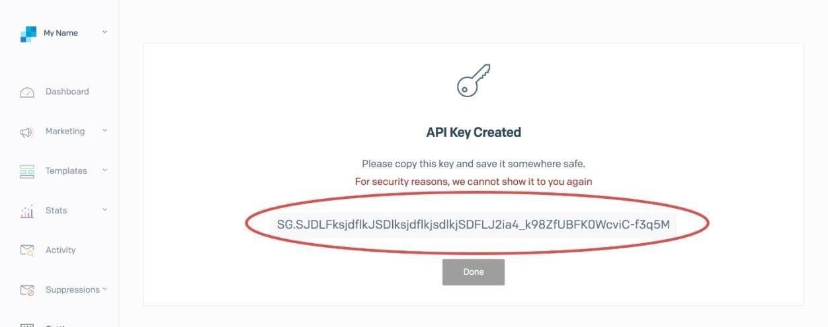

## What are the minimum API restrictions I can allow?

The minimum access you need to allow is as follows:

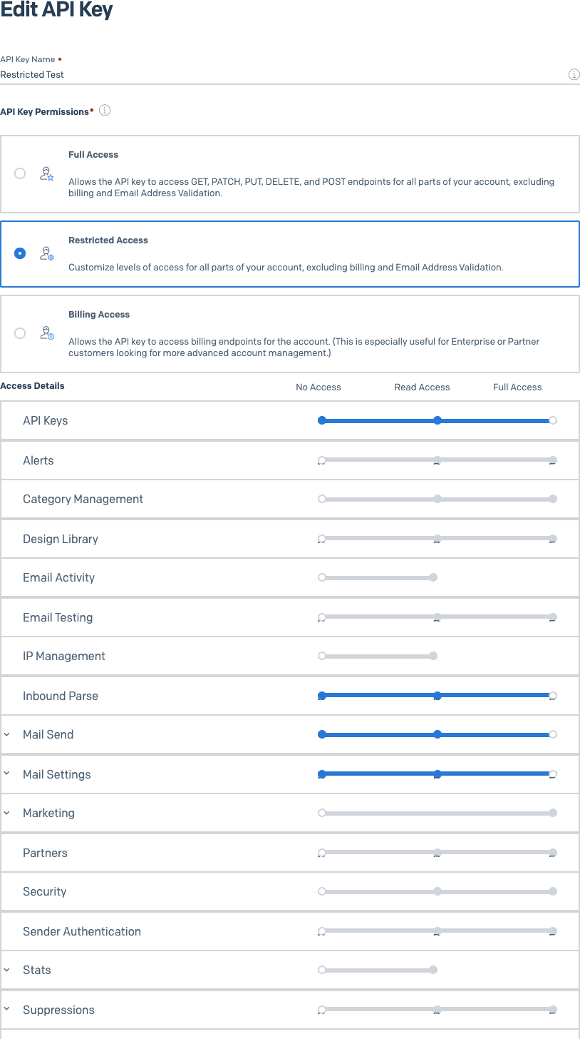

# Step 4. Enable Email Messaging

In OneSignal, navigate to **Settings > Platforms** and click Email to configure your email settings.

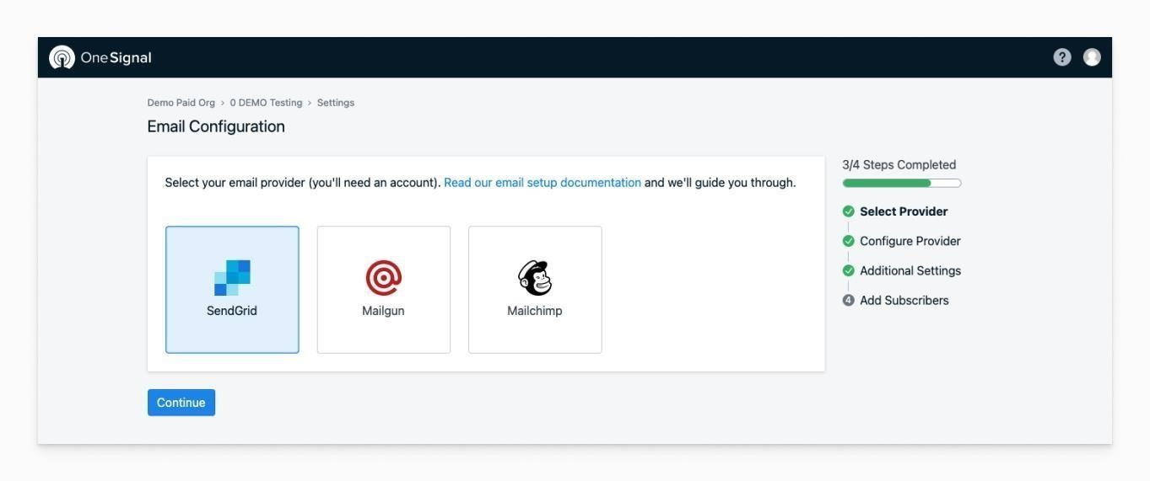Select **SendGrid** as the provider.

Image selecting SendGrid from email settings

Paste your SendGrid API key into the provided field.

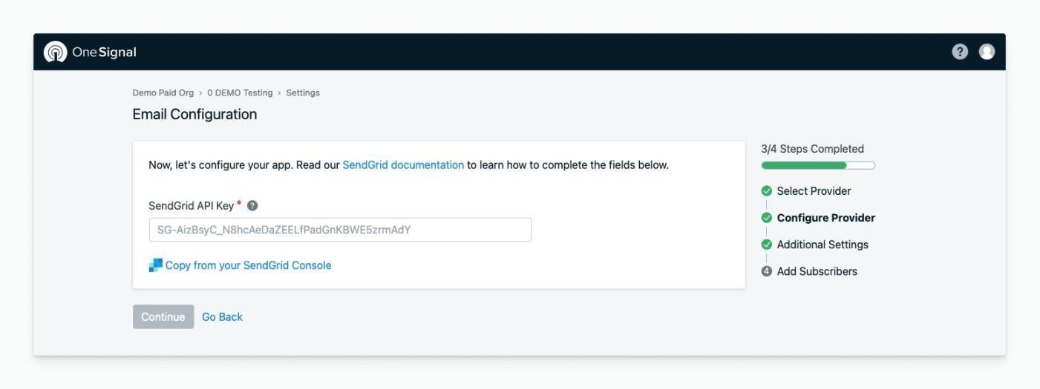

Image showing where to enter your API Key

Delivery Defaults

Add the default **name** and **email address** you want your emails to come from (these can be changed later).

Press Done when finished.

# Step 5. Add Subscribers

If you have a list of emails ready, select **Upload CSV** to [Import Email](https://documentation.onesignal.com/docs/import-email-addresses) [Addresses.](https://documentation.onesignal.com/docs/import-email-addresses) You can always do this again later.

If you have a website and want to prompt users to provide their email. Select **Add Web Prompt** to use OneS

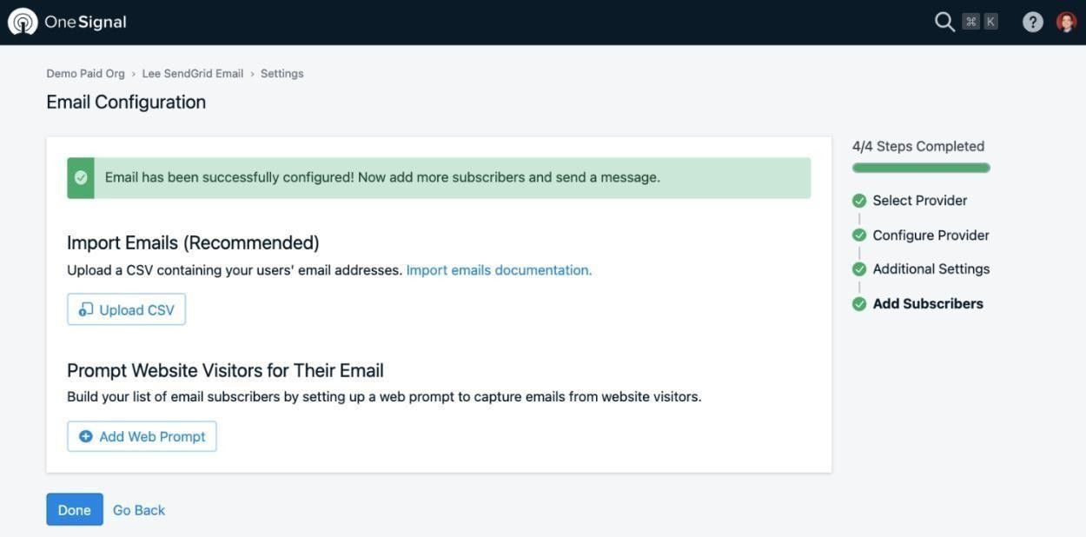

ignal's [Email Web Prompt.](https://documentation.onesignal.com/docs/email-phone-number-web-prompt)

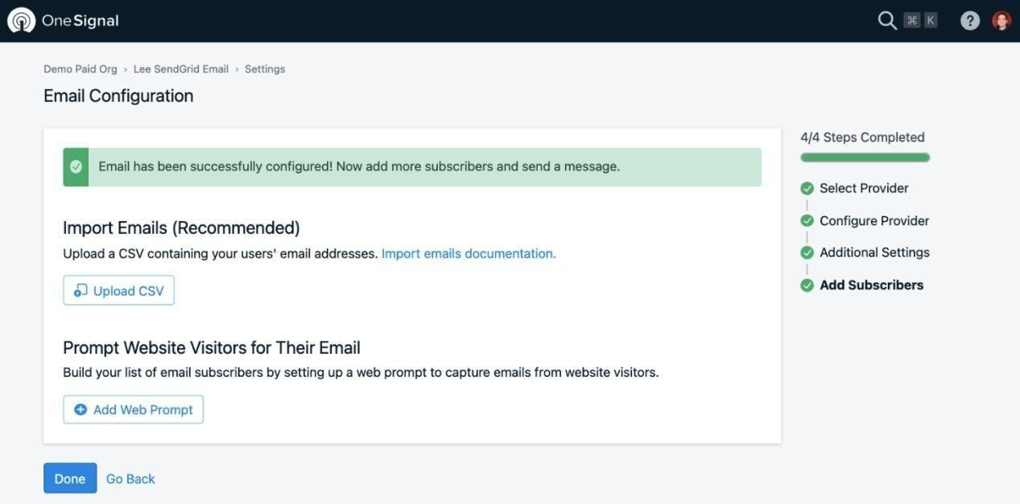

# Step 6. Send Yourself a Test Email

In **OneSignal > Messages > Email**, select **New Email**.

Add a Subject and click **Send Test Email**. Input your email and press **Send Test Message**.

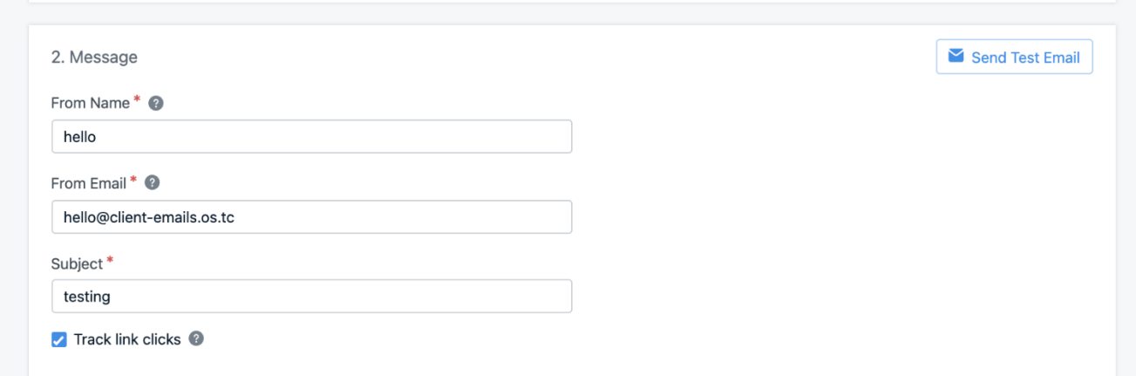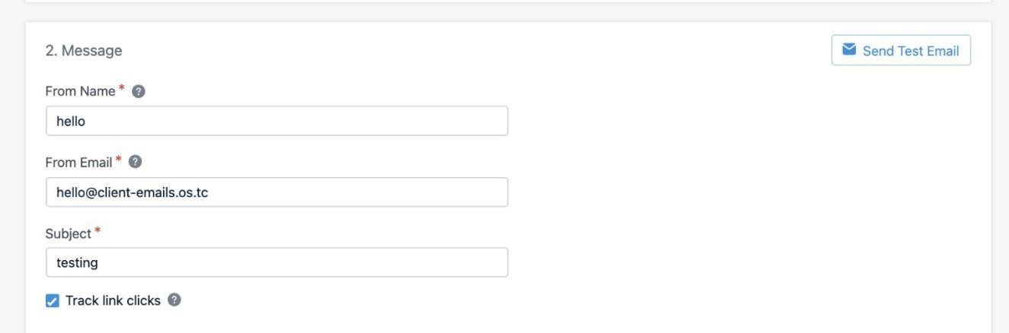

An email should arrive to your inbox shortly!

# Step 7. Set Custom User Properties

OneSignal creates channel-level device records under a unique Id called the player_id. A single user can have multiple player_id records based on how many devices, email addresses, and phone numbers they use to interact with your app.

If your app has its own login system to t rack users, call setExternalUserId at any time to link all channels to a single user. For more details, see [External](https://documentation.onesignal.com/docs/external-user-ids) [User Ids.](https://documentation.onesignal.com/docs/external-user-ids)

All other event and user properties can be set using [Data Tags.](https://documentation.onesignal.com/docs/add-user-data-tags) Setting this data is required for more complex segmentation and message personalization.

# Step 8. Collect New Emails

Emails can be added into OneSignal using the following options outlined in our [Import Email Addresses](https://documentation.onesignal.com/docs/import-email-addresses) guide.

|  |  |
| --- | --- |
| **Option** | **Description** |
| Dashboard Upload | Upload a csv of emails and user dataor manually add emails. |
| Server API | Programmatically add emails server side. |
| SDK setEmail method | Add emailsusing ourclient side  SDK. **Recommended if using our SDKs for push or in-app messaging**. |
| Email Web Prompt | A web prompt that allows user to include their own email address and  phone number. |

